

Eduvos Assessment Coversheet
Academic Details
Campus: | Online Campus
Faculty: | BSc IT
Module Code: | ITNPA3-34
Lecturer’s Name: | Mr. Mavetera. T.
Group (if applicable)
Assessment Details
Assessment Type: | Project
Assignment/Brief Number: | 1
Due Date/ Submission Date: | 2026/11/13
Student Details (Group, if applicable)
# | Full Name | Student Number | Contact Number | % Participation | Signature
1
2
3
Student Details (Individual, if applicable)
Student Full Name: | Lodewikus Joubert
Student Number: | EDUV4818544
Academic Integrity
AI Disclosure Completed | Yes  x | No
Declaration:
I declare that this assessment is my own original work except for source material explicitly acknowledged. I confirm that this work has not previously been submitted for assessments in any course. I acknowledge the institutional AI policy and confirm that AI tools have only been used as stipulated and documented in the AI Disclosure Appendix.

Student Signature | 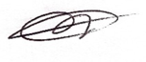
Date | 2026/11/08
Lecturer Use Only
Lecturer Comments:
Marks Awarded (%):
Lecturer Signature:
Date:
Question 1.1
The research_abstracts.json data set was imported into Python using Pandas. The dataset consists of 1,138 research papers in three columns: DOI, Abstract and Label. The data pre-processing was done by checking missing values, removing duplicate abstracts, converting the text into lower case, removing URL, special characters, numbers and unnecessary spaces. The processed abstracts were stored in a new column, clean_text. After the cleaning process, 1121 research papers were left for further analysis.
Code (cell 1-3):
Cell 1:
# Question 1.1
# Import the required libraries
import pandas as pd
import matplotlib.pyplot as plt
from sklearn.model_selection import train_test_split
from sklearn.feature_extraction.text import TfidfVectorizer
from sklearn.linear_model import LogisticRegression
from sklearn.metrics import (
accuracy_score,
f1_score,
classification_report,
ConfusionMatrixDisplay
)
Cell 2:
# Question 1.1
# Load the JSON dataset
df = pd.read_json("research_abstracts.json")
# Display the first five records
display(df.head())
# Check the dataset information
print("Dataset shape:", df.shape)
print("\nColumn names:", df.columns.tolist())
# Check for missing values
print("\nMissing values:")
print(df.isnull().sum())
# Check for duplicate abstracts
print("\nDuplicate abstracts:", df["Abstract"].duplicated().sum())
# Display the research categories
print("\nResearch categories:")
print(df["Label"].value_counts())
Output:
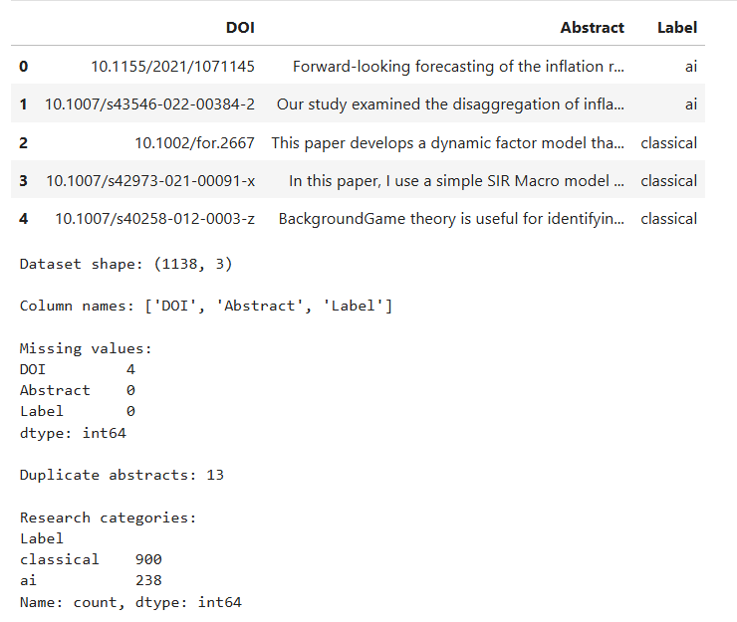
Cell 3:
# Question 1.1
# Remove records with missing abstracts or labels
df = df.dropna(subset=["Abstract", "Label"]).copy()
# Convert abstracts to lowercase
df["clean_text"] = df["Abstract"].str.lower()
# Remove website links
df["clean_text"] = df["clean_text"].str.replace(
r"https?://\S+|www\.\S+", " ", regex=True
)
# Remove numbers and special characters
df["clean_text"] = df["clean_text"].str.replace(
r"[^a-z\s]", " ", regex=True
)
# Remove unnecessary spaces
df["clean_text"] = df["clean_text"].str.replace(
r"\s+", " ", regex=True
).str.strip()
# Remove empty and duplicate cleaned abstracts
df = df[df["clean_text"] != ""]
df = df.drop_duplicates(subset=["clean_text"]).copy()
# Display the cleaned data
print("Cleaned dataset shape:", df.shape)
display(df[["Abstract", "clean_text", "Label"]].head())
Output:
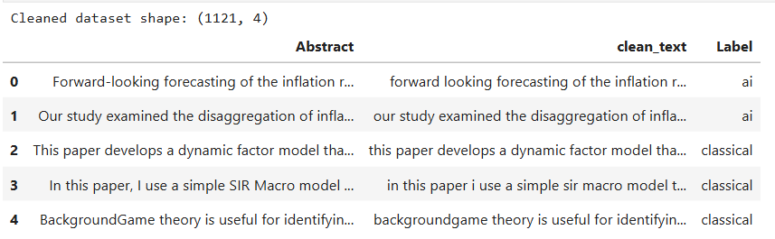
Question 1.2
I have chosen the clean_text column as the input feature and the Label column as the target variable for classification. I decided to remove the DOI column, as it is only used to identify research papers and does not contain any useful information for predicting categories. The text was converted into numerical features using TF-IDF, common English stop words were removed. The dataset was split into training data (80%) and testing data (20%) using stratified sampling, giving 896 training records and 225 testing records. I selected up to 3,000 TF-IDF features to represent important words and word combinations in the research abstracts.
Code (cell 4):
Cell 4:
# Question 1.2
# Select input and target variables
X = df["clean_text"]
y = df["Label"]
# Split data into 80% training and 20% testing
X_train, X_test, y_train, y_test = train_test_split(
X, y,
test_size=0.2,
random_state=42,
stratify=y
)
# Convert text into numerical features using TF-IDF
vectorizer = TfidfVectorizer(
stop_words="english",
max_features=3000,
ngram_range=(1, 2),
min_df=2
)
# Fit only on training data
X_train_tfidf = vectorizer.fit_transform(X_train)
X_test_tfidf = vectorizer.transform(X_test)
# Display feature engineering results
print("Training records:", X_train_tfidf.shape[0])
print("Testing records:", X_test_tfidf.shape[0])
print("Number of TF-IDF features:", X_train_tfidf.shape[1])
# Display some important text terms
terms = vectorizer.get_feature_names_out()
scores = X_train_tfidf.mean(axis=0).A1
top_terms = scores.argsort()[-10:][::-1]
print("\nCommon TF-IDF terms:")
print(terms[top_terms])
Output:
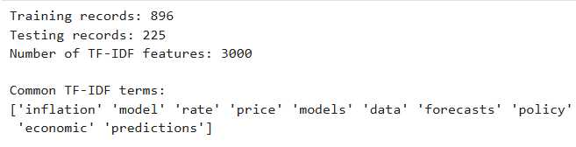
Question 1.3
As a baseline classifier, we used a Logistic Regression model to predict if a research abstract falls into the AI or classical category. The model was trained on the TF-IDF features of the training dataset and tested on the unseen testing data. The model obtained 97.32% training accuracy and 88.89% testing accuracy, showing good learning performance, but the gap between training and testing results is obvious. The training macro F1-score was 0.961 versus 0.838 for the testing data, indicating potential overfitting. The F1-scores on the test set were 0.747 for AI papers and 0.929 for classical papers. The confusion matrix shows 37 correct classifications for AI papers and 163 for classical papers, which means 200 correct classifications out of 225 testing records. Overall, the baseline produced fairly reasonable results but was more accurate for classical research than the minority AI category.
Code (cell 5-7):
Cell 5:
# Question 1.3
# Create the baseline model
model = LogisticRegression(
max_iter=1000,
class_weight="balanced",
random_state=42
)
# Train the model
model.fit(X_train_tfidf, y_train)
# Predict training and testing categories
train_pred = model.predict(X_train_tfidf)
test_pred = model.predict(X_test_tfidf)
print("Model training completed successfully!")
Output:
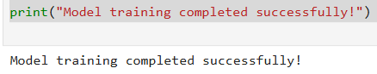
Cell 6:
# Question 1.3
# Calculate training and testing accuracy
train_accuracy = accuracy_score(y_train, train_pred)
test_accuracy = accuracy_score(y_test, test_pred)
# Calculate F1-scores
train_f1 = f1_score(y_train, train_pred, average="macro")
test_f1 = f1_score(y_test, test_pred, average="macro")
# Display the performance results
print("Training Accuracy:", round(train_accuracy * 100, 2), "%")
print("Testing Accuracy:", round(test_accuracy * 100, 2), "%")
print("\nTraining Macro F1-score:", round(train_f1, 3))
print("Testing Macro F1-score:", round(test_f1, 3))
# Display classification performance
print("\nClassification Report:")
print(classification_report(y_test, test_pred, digits=3))
Output:
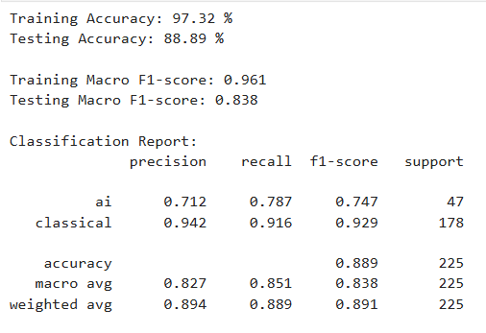
Cell 7:
# Question 1.3
# Display the confusion matrix
ConfusionMatrixDisplay.from_predictions(
y_test,
test_pred,
labels=["ai", "classical"],
display_labels=["AI", "Classical"]
)
plt.title("Confusion Matrix - Research Classification")
plt.show()
Output:
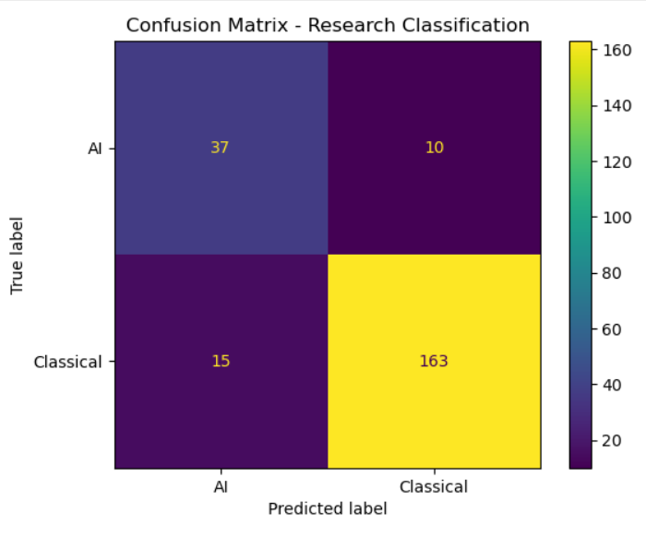
Question 2.1
Four ML models trained on the cleaned research abstracts from Question 1: Multinomial Naive Bayes, Linear Support Vector Machine (SVM), Random Forest and Stochastic Gradient Descent (SGD) Classifier. For a fair comparison, all models used the same TF-IDF features and the same training and testing datasets. The Random Forest model achieved the highest testing accuracy of 90.67% and macro F1-score of 0.832, an improvement over the baseline accuracy of 88.89% for Question 1. Linear SVM with 88.44% testing accuracy, SGD Classifier with 88.00% testing accuracy and Naive Bayes with 85.78% testing accuracy. Random Forest and the two linear classifiers had almost perfect accuracy on training. Their lower accuracy on testing indicates possible overfitting. Overall, Random Forest was the strongest of the four models based on the testing accuracy and macro F1-score in the saved notebook results.
Code (cell 8-9):
Cell 8:
# Question 2.1
# Import libraries for the four machine learning models
from sklearn.pipeline import Pipeline
from sklearn.naive_bayes import MultinomialNB
from sklearn.svm import LinearSVC
from sklearn.ensemble import RandomForestClassifier
from sklearn.linear_model import SGDClassifier
Cell 9:
# Question 2.1
# Define the four models
models = {
"Naive Bayes": MultinomialNB(),
"Linear SVM": LinearSVC(class_weight="balanced", random_state=42),
"Random Forest": RandomForestClassifier(
n_estimators=150,
class_weight="balanced",
random_state=42,
n_jobs=-1
),
"SGD Classifier": SGDClassifier(
loss="hinge",
class_weight="balanced",
random_state=42
)
}
# Store model results
results = []
trained_models = {}
# Train and evaluate each model
for name, classifier in models.items():
pipeline = Pipeline([
("tfidf", TfidfVectorizer(
stop_words="english",
max_features=3000,
ngram_range=(1, 2),
min_df=2
)),
("model", classifier)
])
pipeline.fit(X_train, y_train)
train_pred = pipeline.predict(X_train)
test_pred = pipeline.predict(X_test)
results.append({
"Model": name,
"Training Accuracy": round(accuracy_score(y_train, train_pred) * 100, 2),
"Testing Accuracy": round(accuracy_score(y_test, test_pred) * 100, 2),
"Test Macro F1": round(f1_score(y_test, test_pred, average="macro"), 3)
})
trained_models[name] = pipeline
# Display comparison results
results_df = pd.DataFrame(results)
display(results_df.sort_values("Test Macro F1", ascending=False))
Output:
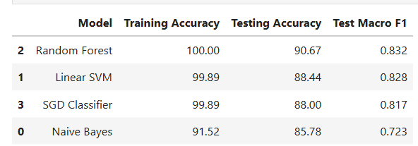
Question 2.2
To improve the power of prediction, I incorporated character-level TF-IDF feature extraction and the Linear SVM model. This approach is different from word-level TF-IDF by considering smaller sequences of characters that can represent associated words and word forms . I used character sequences of length 3-5 and up to 30,000 features. The original Linear SVM model obtained a testing accuracy of 88.44% with a macro F1-score of 0.828. Character-level TF-IDF boosted accuracy to 92.44% and macro F1-score to 0.879. The improved model correctly classified 35 AI papers and 173 classical papers, 208 out of 225 testing abstracts in total. This demonstrates that better text feature representation can improve predictive performance without changing the underlying Linear SVM algorithm.
Code (cell 10-11):
Cell 10:
# Question 2.2
# Improve Linear SVM using character-level TF-IDF
improved_model = Pipeline([
("tfidf", TfidfVectorizer(
analyzer="char_wb",
ngram_range=(3, 5),
max_features=30000,
min_df=2,
sublinear_tf=True
)),
("model", LinearSVC(
class_weight="balanced",
random_state=42
))
])
# Train the improved model
improved_model.fit(X_train, y_train)
# Make predictions
improved_pred = improved_model.predict(X_test)
# Get original SVM predictions
original_pred = trained_models["Linear SVM"].predict(X_test)
# Compare original and improved SVM
comparison = pd.DataFrame({
"Model": ["Original SVM", "Improved SVM"],
"Accuracy": [
round(accuracy_score(y_test, original_pred) * 100, 2),
round(accuracy_score(y_test, improved_pred) * 100, 2)
],
"Macro F1": [
round(f1_score(y_test, original_pred, average="macro"), 3),
round(f1_score(y_test, improved_pred, average="macro"), 3)
]
})
display(comparison)
Output:
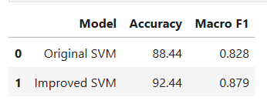
Cell 11:
# Question 2.2
# Display the classification report
print("Improved Model Classification Report:")
print(classification_report(y_test, improved_pred, digits=3))
# Display the confusion matrix
ConfusionMatrixDisplay.from_predictions(
y_test,
improved_pred,
labels=["ai", "classical"],
display_labels=["AI", "Classical"],
cmap="Blues"
)
plt.title("Improved SVM Confusion Matrix")
plt.show()
Output:
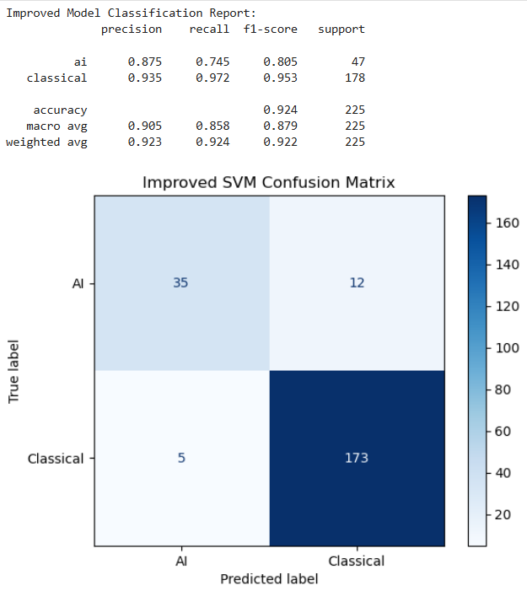
Question 2.3
I implemented the best performing configuration, which is Linear SVM with character level TF-IDF features, using the python framework Streamlit . The improved model achieved a testing accuracy of 92.44% and a macro F1-score of 0.879 in the evaluation. The selected model was then re-trained on all the cleaned research abstracts and saved as a Joblib file after evaluation. I built a web interface where a user can input an abstract, click a classify button, and see a prediction whether it is classical research or artificial intelligence. The application performs the same preprocessing steps as performed during training and loads the saved classifier to predict the category. We used the application to process sample abstracts and confirmed that the web interface performs as expected.
Code (cell 12-15):
Cell 12:
# Question 2.3
# Save the model
# Import libraries for saving the model
import joblib
from sklearn.base import clone
# Retrain the selected model using all cleaned records
final_model = clone(improved_model)
final_model.fit(
df["clean_text"],
df["Label"]
)
# Save the model
joblib.dump(final_model, "research_classifier.joblib")
print("Model saved successfully!")
Output:
Model saved successfully!
Cell 13:
# Question 2.3
# Install Streamlit for the web application
%pip install streamlit joblib
Output:
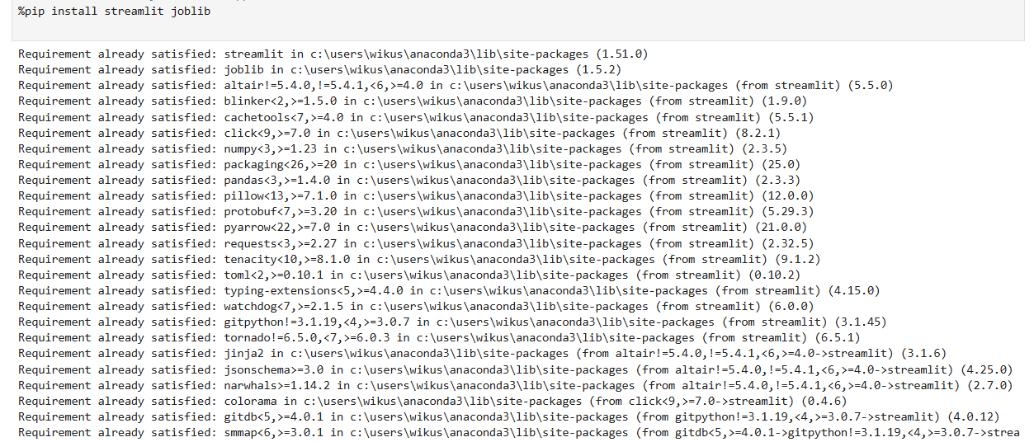
Cell 14:
%%writefile app.py
import streamlit as st
import joblib
import re
from pathlib import Path
# Configure the web page
st.set_page_config(
page_title="Researchly Research Abstract Classifier",
layout="centered"
)
# Load the saved model
@st.cache_resource
def load_model():
model_path = Path(__file__).parent / "research_classifier.joblib"
return joblib.load(model_path)
# Apply the same text cleaning used during training
def clean_text(text):
text = text.lower()
text = re.sub(r"https?://\S+|www\.\S+", " ", text)
text = re.sub(r"[^a-z\s]", " ", text)
text = re.sub(r"\s+", " ", text).strip()
return text
# Display the title and description
st.title("Researchly Research Abstract Classifier")
st.write(
"This app classifies research abstracts as either "
"AI-related or classical research."
)
# Text input field
abstract = st.text_area(
"Enter research abstract:",
height=180,
placeholder="Paste your research abstract here..."
)
# Classification button
if st.button("Classify Abstract"):
cleaned_abstract = clean_text(abstract)
if cleaned_abstract == "":
st.warning("Please enter a research abstract.")
else:
# Predict the research category
model = load_model()
prediction = model.predict([cleaned_abstract])[0]
st.subheader("Prediction")
if prediction == "ai":
st.success(
"The abstract is classified as: artificial intelligence"
)
else:
st.success(
"The abstract is classified as: classical research"
)
Output:
Writing app.py
Cell 15:
# Question 2.3
# Create requirements file
import sklearn
with open("requirements.txt", "w") as file:
file.write("streamlit\n")
file.write(f"scikit-learn=={sklearn.__version__}\n")
file.write("joblib\n")
print("Requirements file created successfully!")
Output:
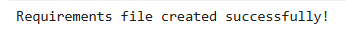
Cell 16:
import os
print(os.getcwd())
Output:
C:\Users\wikus\Research_Expert_System (path recorded when the notebook was run; folder has since been reorganised)
Web application deployment (Anaconda Prompt):
Run the following command from the project folder while app.py and research_classifier.joblib are together:
- python -m streamlit run app.py
Output:
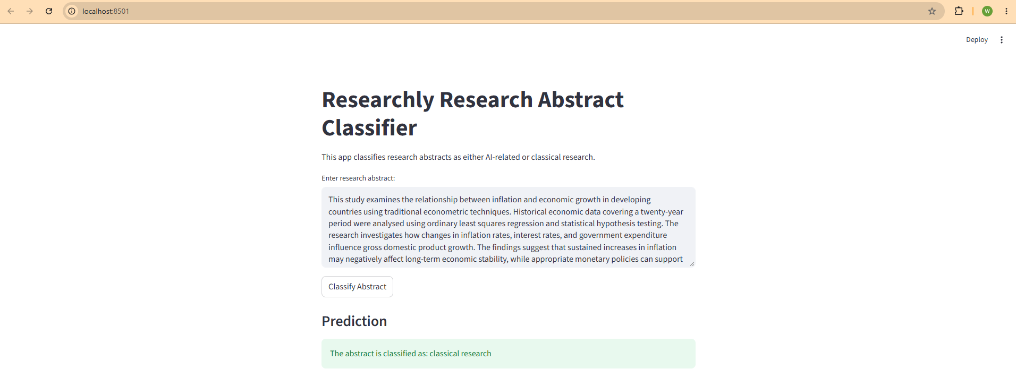
Question 3.1
I used Python and Pandas to load the five supplied research text files into one DataFrame. Each row represents a research article and contains its article number, filename, full supplied content and word count. This gives a structured dataset for document preprocessing, summarization and topic analysis.
Code (cell 1-2):
Cell 1:
# Question 3.1
# Import the required libraries
import re
import unicodedata
from pathlib import Path
import numpy as np
import pandas as pd
import matplotlib.pyplot as plt
from nltk.stem import SnowballStemmer
from sklearn.feature_extraction.text import (
TfidfVectorizer,
ENGLISH_STOP_WORDS
)
from sklearn.metrics.pairwise import cosine_similarity
from sklearn.decomposition import TruncatedSVD, NMF
Cell 2:
# Question 3.1
# Read all five text files
files = [Path(f"research_{i}.txt") for i in range(1, 6)]
records = []
for i, file in enumerate(files, start=1):
content = file.read_text(encoding="utf-8-sig")
records.append({
"Article": f"Article {i}",
"Filename": file.name,
"Content": content,
"Word_Count": len(content.split())
})
# Create the DataFrame
df = pd.DataFrame(records)
# Display the dataset
print("Number of articles:", len(df))
display(df)
# Preview content of the first article
print("\nFirst article preview:\n", df.loc[0, "Content"][:500])
Output:
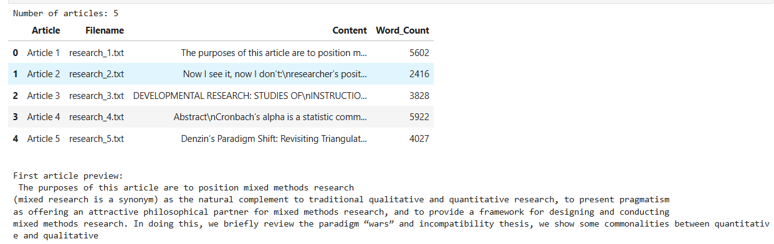
Question 3.2
I pre-processed each article by normalizing Unicode characters, repairing words split across line breaks, removing URLs and email addresses, converting text to lowercase and removing punctuation, numbers and common English stop words. I also applied Snowball stemming to produce a simplified version of each text. The original article content was retained, and separate cleaned text columns were created for further analysis.
Code (cell 3-4):
Cell 3:
# Question 3.2
# Define stop words
stop_words = set(ENGLISH_STOP_WORDS) | {
"et", "al", "http", "https", "www",
"doi", "article", "articles", "author", "authors"
}
# Create the stemmer
stemmer = SnowballStemmer("english")
# Function to clean research text
def clean_text(text):
# Normalize Unicode characters
text = unicodedata.normalize("NFKC", text)
# Repair words broken across lines
text = re.sub(r"(?<=\w)-\s*\n\s*(?=\w)", "", text)
# Remove URLs and email addresses
text = re.sub(
r"https?://\S+|www\.\S+|\S+@\S+",
" ", text
)
# Convert to lowercase and remove special characters
text = re.sub(r"[^a-zA-Z\s]", " ", text.lower())
# Remove short words and stop words
words = re.findall(r"[a-z]{3,}", text)
return " ".join(
word for word in words if word not in stop_words
)
# Apply preprocessing
df["Clean_Text"] = df["Content"].apply(clean_text)
# Apply stemming
df["Stemmed_Text"] = df["Clean_Text"].apply(
lambda text: " ".join(
stemmer.stem(word) for word in text.split()
)
)
# Calculate cleaned word counts
df["Clean_Word_Count"] = (
df["Clean_Text"].str.split().str.len()
)
# Display results
display(df[[
"Article", "Word_Count", "Clean_Word_Count"
]])
print("\nExample cleaned text:\n",
df.loc[0, "Clean_Text"][:350])
print("\nExample stemmed text:\n",
df.loc[0, "Stemmed_Text"][:350])
Output:
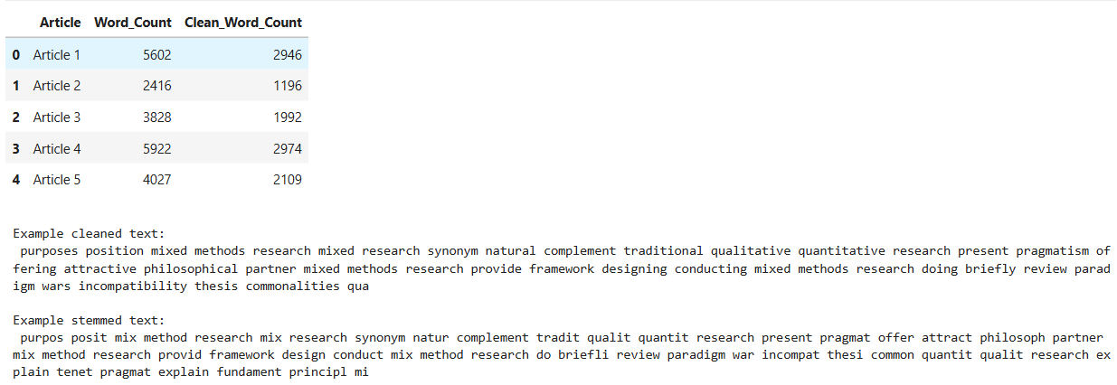
Cell 4:
# Question 3.2
# Compare word counts before and after preprocessing
positions = np.arange(len(df))
plt.figure(figsize=(9, 4))
plt.bar(
positions - 0.2,
df["Word_Count"],
width=0.4,
label="Original"
)
plt.bar(
positions + 0.2,
df["Clean_Word_Count"],
width=0.4,
label="Cleaned"
)
plt.xticks(positions, df["Article"])
plt.ylabel("Number of words")
plt.title("Research articles before and after preprocessing")
plt.legend()
plt.tight_layout()
plt.show()
Output:
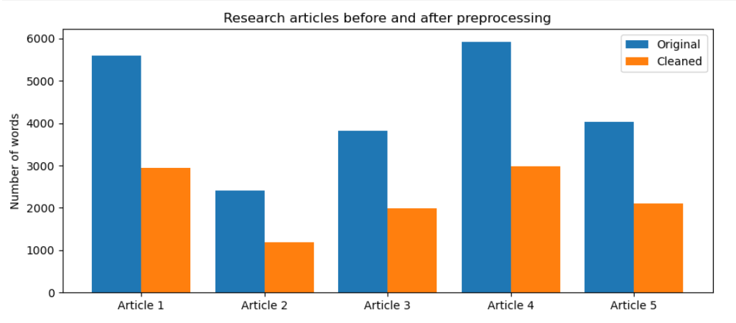
Question 3.3
I employed extractive summarisation based on TF-IDF sentence similarity for Article 1. The article was split up into sentences, with duplicate sentences removed, and each sentence was given a score based on its similarity to the overall article text. The sentences with the highest scores were selected as the summary and their scores were plotted in a bar chart. The primary contention of the article is that mixed methods research can combine the benefits of qualitative and quantitative approaches and pragmatism provides a suitable philosophical foundation.
Code (cell 5-7):
Cell 5:
# Question 3.3
# Function to split research articles into sentences
def get_sentences(text):
# Repair broken words and spaces
text = re.sub(r"(?<=\w)-\s*\n\s*(?=\w)", "", text)
text = re.sub(r"\s+", " ", text)
# Split the text into sentences
sentences = re.split(
r'(?<=[.!?])\s+(?=[A-Z“"0-9])',
text
)
# Remove repeated and unsuitable sentences
unique = []
seen = set()
for sentence in sentences:
if not 12 <= len(sentence.split()) <= 75:
continue
key = re.sub(
r"[^a-z]+", " ", sentence.lower()
).strip()
if key not in seen:
seen.add(key)
unique.append(sentence.strip())
return unique
# Extract sentences from Article 1
first_sentences = get_sentences(df.loc[0, "Content"])
print("Usable sentences in Article 1:",
len(first_sentences))
Output:
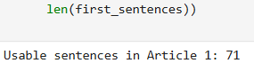
Cell 6:
# Question 3.3
# Convert sentences into TF-IDF features
tfidf = TfidfVectorizer(
stop_words="english",
ngram_range=(1, 2),
max_features=5000
)
sentence_vectors = tfidf.fit_transform(first_sentences)
# Calculate average TF-IDF representation
article_vector = np.asarray(
sentence_vectors.mean(axis=0)
)
# Calculate sentence importance scores
sentence_scores = cosine_similarity(
sentence_vectors,
article_vector
).ravel()
# Select five important sentences
summary_ids = sorted(
np.argsort(sentence_scores)[-5:]
)
# Display the summary
print("SUMMARY OF ARTICLE 1:\n")
for i in summary_ids:
print(first_sentences[i], "\n")
Output:
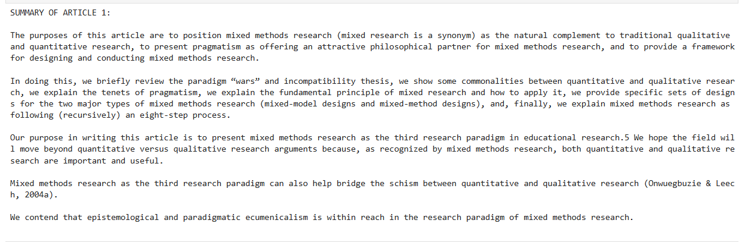
Cell 7:
# Question 3.3
# Select the eight highest-scoring sentences
top_ids = np.argsort(sentence_scores)[-8:][::-1]
# Display the sentence importance scores
plt.figure(figsize=(8, 4))
plt.barh(
[f"Sentence {i + 1}" for i in top_ids[::-1]],
sentence_scores[top_ids][::-1]
)
plt.xlabel("TF-IDF similarity score")
plt.title("Most important sentences in Article 1")
plt.tight_layout()
plt.show()
Output:
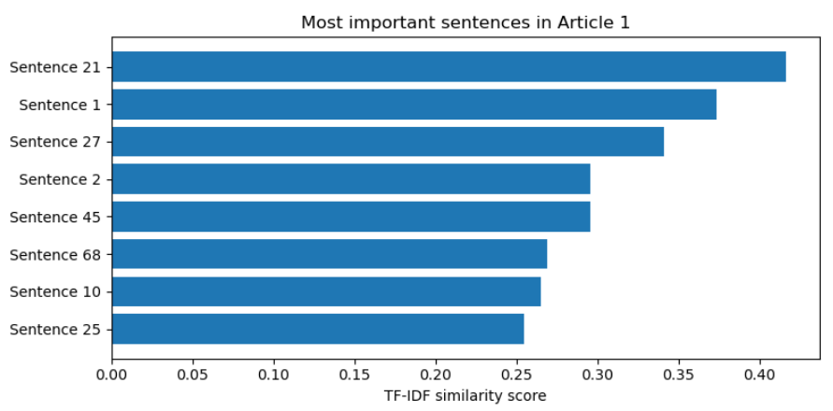
Question 3.4
Then I combined Articles 2-5 and applied another extractive summarisation technique called Latent Semantic Analysis (LSA) to identify relevant sentences from the four articles. I selected representative sentences from each article to maintain coverage. I then applied Non-negative Matrix Factorisation (NMF) topic modelling to smaller text segments, and visualised the strength of each article’s association with the discovered topics. The dominant themes were qualitative research and reflexivity or triangulation, developmental and instructional design, and Cronbach’s alpha and measurement reliability. Since the corpus provided is not a corpus of recent AI research papers, these results are research methodology themes, not AI research trends.
Code (cell 8-11):
Cell 8:
# Question 3.4
# Combine the sentences from Articles 2 to 5
all_sentences = []
article_sources = []
for i in range(1, 5):
sentences = get_sentences(df.loc[i, "Content"])
all_sentences.extend(sentences)
article_sources.extend(
[df.loc[i, "Article"]] * len(sentences)
)
# Convert sentences into numerical features
lsa_tfidf = TfidfVectorizer(
stop_words="english",
max_features=5000,
ngram_range=(1, 2)
)
lsa_matrix = lsa_tfidf.fit_transform(all_sentences)
# Apply Latent Semantic Analysis
lsa = TruncatedSVD(
n_components=3,
random_state=42
)
lsa_sentence_vectors = lsa.fit_transform(lsa_matrix)
# Calculate sentence importance
lsa_scores = np.linalg.norm(
lsa_sentence_vectors,
axis=1
)
# Select two important sentences from each article
selected = []
for article in [
"Article 2", "Article 3",
"Article 4", "Article 5"
]:
ids = np.where(
np.array(article_sources) == article
)[0]
selected.extend(
sorted(ids[np.argsort(lsa_scores[ids])[-2:]])
)
# Display aggregate summary
print("AGGREGATE SUMMARY OF ARTICLES 2 TO 5:\n")
for i in selected:
print(
article_sources[i] + ":",
all_sentences[i],
"\n"
)
Output:
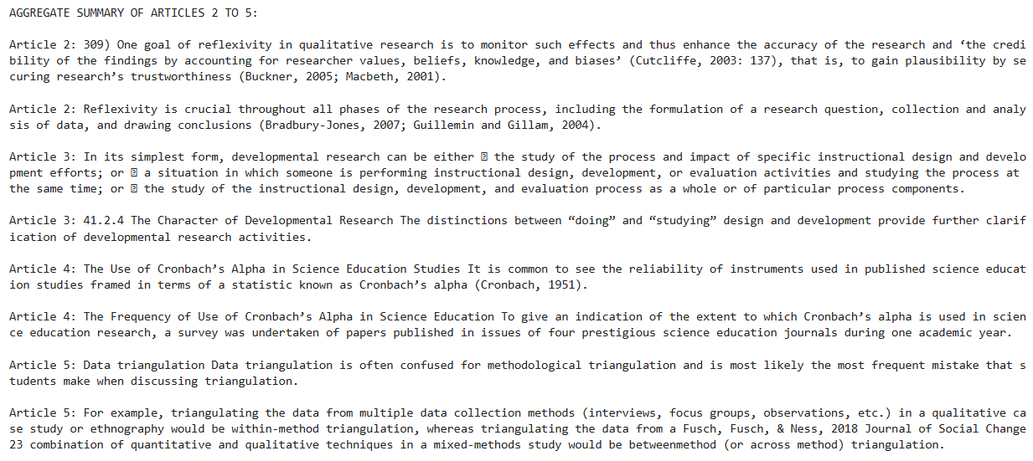
Cell 9:
#Question 3.4
# Divide cleaned articles into shorter text sections
chunks = []
chunk_sources = []
for i in range(1, 5):
words = df.loc[i, "Clean_Text"].split()
for start in range(0, len(words), 120):
piece = " ".join(words[start:start + 120])
if len(piece.split()) >= 40:
chunks.append(piece)
chunk_sources.append(df.loc[i, "Article"])
# Convert text sections into TF-IDF features
topic_tfidf = TfidfVectorizer(
max_features=2500,
min_df=2,
max_df=0.9,
ngram_range=(1, 2)
)
topic_matrix = topic_tfidf.fit_transform(chunks)
# Apply NMF topic modelling
nmf = NMF(
n_components=3,
init="nndsvda",
random_state=42,
max_iter=600
)
chunk_topics = nmf.fit_transform(topic_matrix)
# Get the topic keywords
terms = topic_tfidf.get_feature_names_out()
# Display the most important words in each topic
for t, weights in enumerate(nmf.components_, start=1):
top = np.argsort(weights)[-10:][::-1]
print(
f"Topic {t}:",
", ".join(terms[top])
)
Output:
Cell 10:
# Question 3.4
# Calculate topic importance for each article
source_array = np.array(chunk_sources)
topic_rows = []
for article in [
"Article 2", "Article 3",
"Article 4", "Article 5"
]:
mean_weight = chunk_topics[
source_array == article
].mean(axis=0)
topic_rows.append(
mean_weight / mean_weight.sum()
)
# Create topic distribution DataFrame
topic_df = pd.DataFrame(
topic_rows,
index=[
"Article 2", "Article 3",
"Article 4", "Article 5"
],
columns=["Topic 1", "Topic 2", "Topic 3"]
)
display(topic_df.round(3))
# Plot the heatmap
plt.figure(figsize=(8, 4))
plt.imshow(
topic_df,
aspect="auto",
cmap="Blues",
vmin=0,
vmax=1
)
plt.colorbar(label="Relative topic importance")
plt.xticks(range(3), topic_df.columns)
plt.yticks(range(4), topic_df.index)
# Display values inside the heatmap
for i in range(4):
for j in range(3):
plt.text(
j, i,
f"{topic_df.iloc[i, j]:.2f}",
ha="center",
va="center",
color="black"
)
plt.title("Topic distribution across Articles 2–5")
plt.tight_layout()
plt.show()
Output:
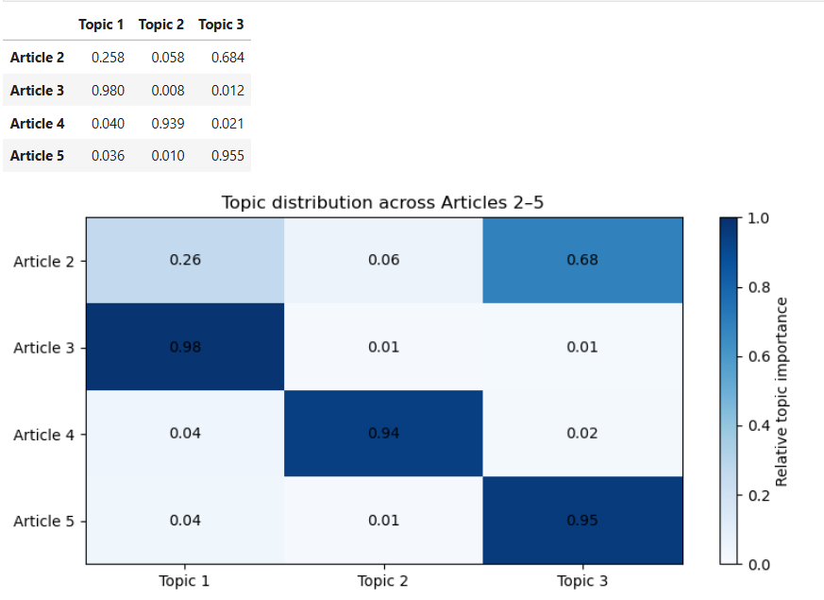
Cell 11:
# Question 3.4
# Plot the main words belonging to each topic
fig, axes = plt.subplots(1, 3, figsize=(15, 4))
for topic_id, ax in enumerate(axes):
weights = nmf.components_[topic_id]
best = np.argsort(weights)[-7:]
ax.barh(
terms[best],
weights[best]
)
ax.set_title(f"Topic {topic_id + 1}")
ax.set_xlabel("Word importance")
plt.suptitle("Top words in the three discovered topics")
plt.tight_layout()
plt.show()
Output:
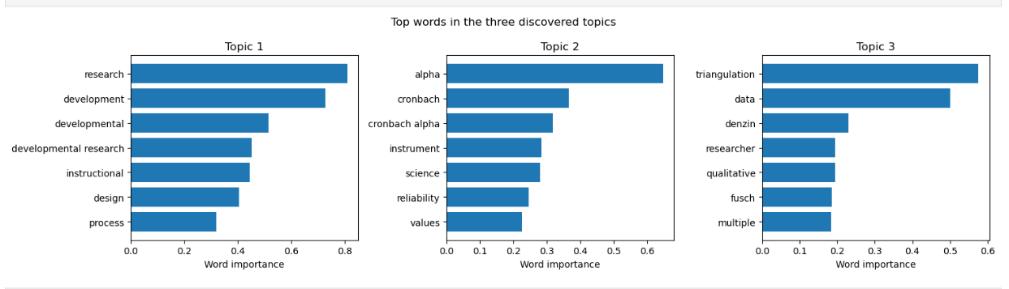
Question 4.1
I used Latent Dirichlet Allocation (LDA) to extract four topics from the five research documents provided. The original articles were loaded into a Pandas DataFrame and were cleaned by text normalisation, removal of URLs and punctuation, lowercasing and stop-word filtering. The articles were divided into smaller pieces of text to create more observations for the topic model. The sections were transformed into a document-term matrix using a CountVectorizer based on word frequencies. Then I trained LDA and displayed the ten most important words for each topic and the average topic distribution for each article. The main themes and the relationship between articles were visualised using bar charts and a heatmap. The number of research-methodology articles in this corpus is small (five), so the identified topics are exploratory and do not show trends over time.
Code (cell 1-7):
Cell 1:
# Question 4.1
# Import the required libraries
import re
import unicodedata
from pathlib import Path
import numpy as np
import pandas as pd
import matplotlib.pyplot as plt
from sklearn.feature_extraction.text import (
CountVectorizer,
ENGLISH_STOP_WORDS
)
from sklearn.decomposition import LatentDirichletAllocation
from IPython.display import display, FileLink
Cell 2:
# Question 4.1
# Load the five research articles
files = [Path(f"research_{i}.txt") for i in range(1, 6)]
records = []
for i, file in enumerate(files, start=1):
content = file.read_text(encoding="utf-8-sig")
records.append({
"Article": f"Article {i}",
"Filename": file.name,
"Content": content,
"Word_Count": len(content.split())
})
# Create a DataFrame
df = pd.DataFrame(records)
print("Articles loaded:", len(df))
display(df[["Article", "Filename", "Word_Count"]])
Output:
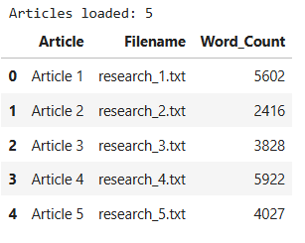
Cell 3:
# QUestion 4.1
# Define stop words
stop_words = set(ENGLISH_STOP_WORDS) | {
"et", "al", "http", "https", "www",
"doi", "article", "articles", "journal",
"vol", "volume", "pp", "page", "pages",
"copyright", "publisher", "issn",
"email", "university", "researcher", "researchers"
}
# Clean the research text
def clean_text(text):
text = unicodedata.normalize("NFKC", text)
text = re.sub(
r"(?<=\w)-\s*\n\s*(?=\w)", "", text
)
text = re.sub(
r"https?://\S+|www\.\S+|\S+@\S+",
" ", text
)
words = re.findall(r"[a-z]{3,}", text.lower())
return " ".join(
word for word in words if word not in stop_words
)
# Apply cleaning
df["Clean_Text"] = df["Content"].apply(clean_text)
# Divide cleaned documents into smaller sections
chunks = []
chunk_sources = []
for _, row in df.iterrows():
words = row["Clean_Text"].split()
for start in range(0, len(words), 120):
section = words[start:start + 120]
if len(section) >= 40:
chunks.append(" ".join(section))
chunk_sources.append(row["Article"])
print("Number of article sections:", len(chunks))
print("\nSections per article:")
print(pd.Series(chunk_sources).value_counts().sort_index())
Output:
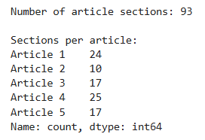
Cell 4:
# Question 4.1
# Convert research text into word counts
vectorizer = CountVectorizer(
max_features=1600,
min_df=2,
max_df=0.95
)
doc_term_matrix = vectorizer.fit_transform(chunks)
# Train the LDA topic model
lda_model = LatentDirichletAllocation(
n_components=4,
random_state=42,
learning_method="batch",
max_iter=10
)
doc_topic_matrix = lda_model.fit_transform(
doc_term_matrix
)
print("Document-term matrix shape:", doc_term_matrix.shape)
print("Number of topics:", lda_model.n_components)
print("LDA training completed successfully!")
Output:
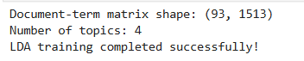
Cell 5:
# Question 4.1
# Display the top 10 words for each topic
terms = vectorizer.get_feature_names_out()
topic_words = {}
for topic_id, weights in enumerate(
lda_model.components_, start=1
):
top_ids = weights.argsort()[-10:][::-1]
words = terms[top_ids].tolist()
topic_words[f"Topic {topic_id}"] = words
print(f"Topic {topic_id}:", ", ".join(words))
# Calculate average topic distribution for each article
article_topics = []
source_array = np.array(chunk_sources)
for article in df["Article"]:
article_topics.append(
doc_topic_matrix[
source_array == article
].mean(axis=0)
)
topic_df = pd.DataFrame(
article_topics,
index=df["Article"],
columns=[f"Topic {i}" for i in range(1, 5)]
)
print("\nTopic distribution per article:")
display(topic_df.round(3))
Output:
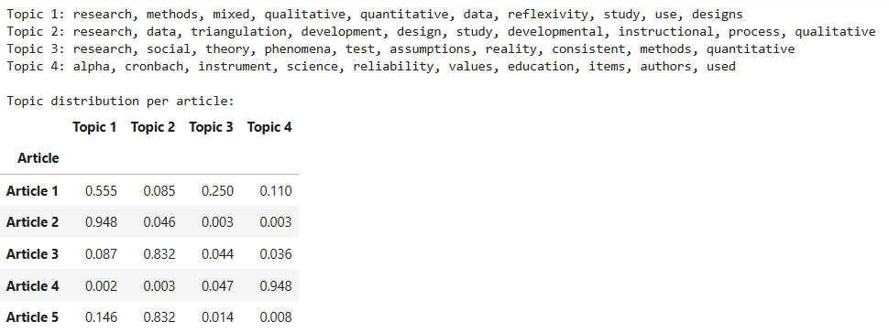
Cell 6:
# Question 4.1
# Visualize the top words for each topic
fig, axes = plt.subplots(2, 2, figsize=(13, 9))
for idx, ax in enumerate(axes.flat):
weights = lda_model.components_[idx]
top_ids = weights.argsort()[-10:]
ax.barh(
terms[top_ids],
weights[top_ids]
)
ax.set_title(f"Topic {idx + 1}")
ax.set_xlabel("Word weight")
plt.suptitle("Top 10 words in each LDA topic")
plt.tight_layout()
plt.show()
Output:
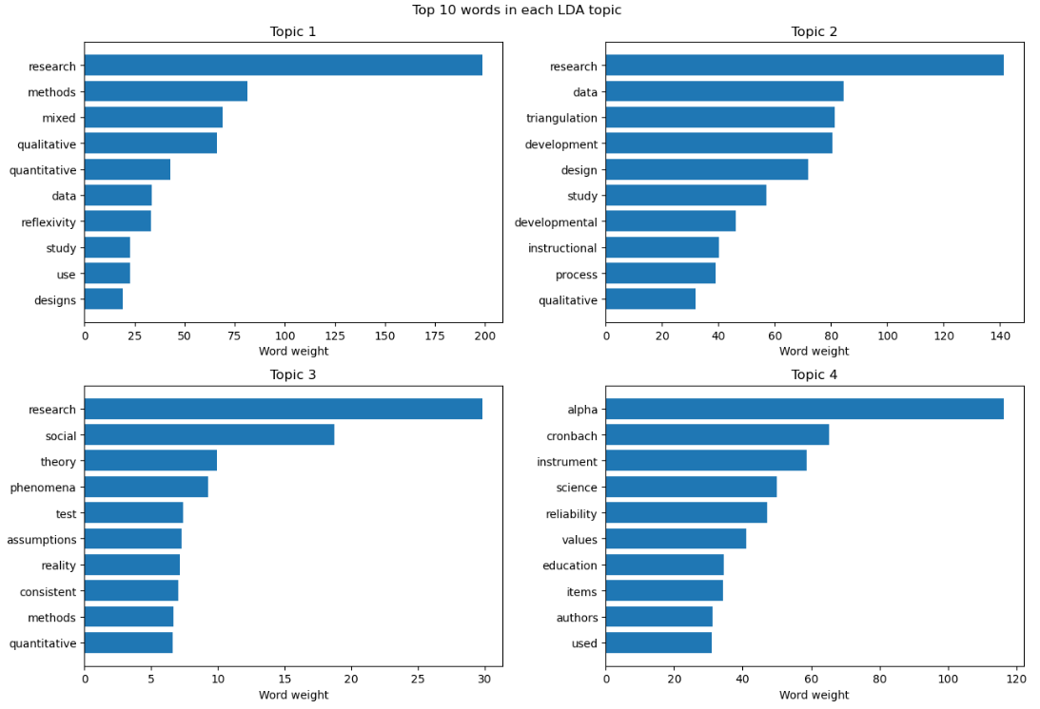
Cell 7:
# Question 4.1
# Create a topic distribution heatmap
plt.figure(figsize=(9, 5))
plt.imshow(
topic_df.values,
cmap="Blues",
vmin=0,
vmax=1,
aspect="auto"
)
plt.colorbar(label="Average topic probability")
plt.xticks(range(4), topic_df.columns)
plt.yticks(range(5), topic_df.index)
# Add values to the heatmap
for i in range(len(topic_df)):
for j in range(4):
value = topic_df.iloc[i, j]
plt.text(
j, i,
f"{value:.2f}",
ha="center",
va="center",
color="white" if value > 0.55 else "black"
)
plt.title("LDA topic distribution across the five research articles")
plt.tight_layout()
plt.show()
Output:
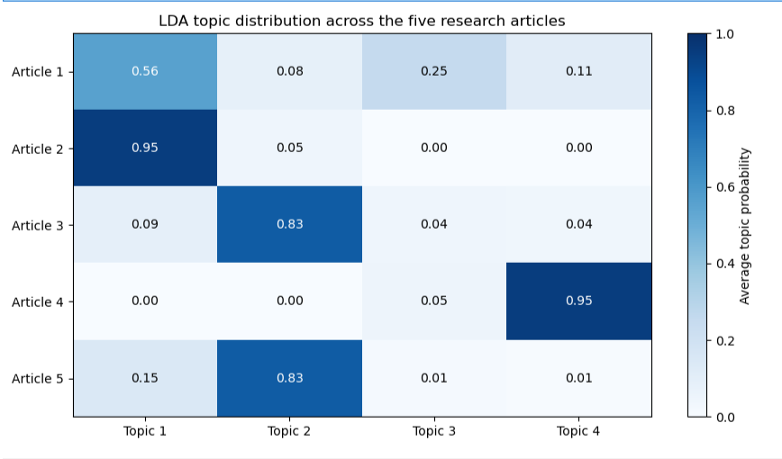
Question 4.2
I used the pyLDAvis package to create an interactive intertopic distance map from the four-topic LDA model. The map displays each topic as a circle, with circle size indicating its relative prevalence and distance suggesting how different topics are from one another. Selecting a topic displays its most relevant words and estimated frequencies, while the relevance slider allows the user to explore the vocabulary associated with that topic. The visualization was also saved as an HTML file so that it could be opened separately in a web browser and included as project evidence.
Code (cell 8-9):
Cell 8:
# QUestion 4.2
# Install pyLDAvis
%pip install pyLDAvis
Output:
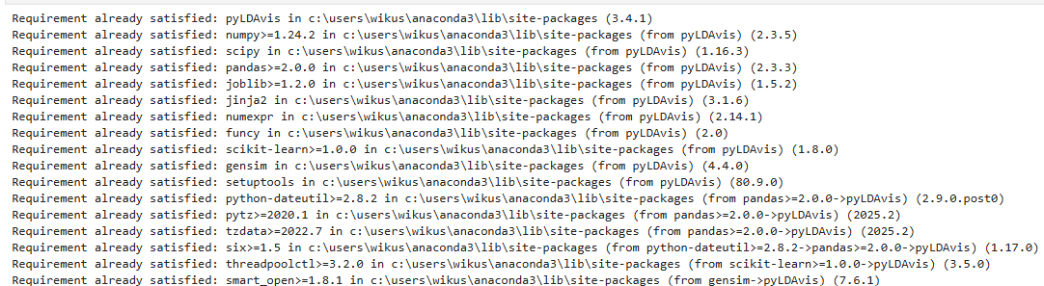
Cell 9:
# Question 4.2
# Import pyLDAvis
import pyLDAvis
# Prepare topic and word probabilities
term_counts = np.asarray(
doc_term_matrix.sum(axis=0)
).ravel()
doc_lengths = np.asarray(
doc_term_matrix.sum(axis=1)
).ravel()
topic_term = (
lda_model.components_
/ lda_model.components_.sum(axis=1)[:, None]
)
# Create the interactive visualization
vis = pyLDAvis.prepare(
topic_term_dists=topic_term,
doc_topic_dists=doc_topic_matrix,
doc_lengths=doc_lengths,
vocab=vectorizer.get_feature_names_out(),
term_frequency=term_counts,
mds="pcoa",
sort_topics=False,
n_jobs=1
)
# Save the visualization as an HTML file
pyLDAvis.save_html(
vis,
"lda_intertopic_map.html"
)
print("Interactive map saved successfully!")
# Display the map inside Jupyter Notebook
display(pyLDAvis.display(vis))
# Provide a link to the saved HTML file
display(FileLink("lda_intertopic_map.html"))
Output:
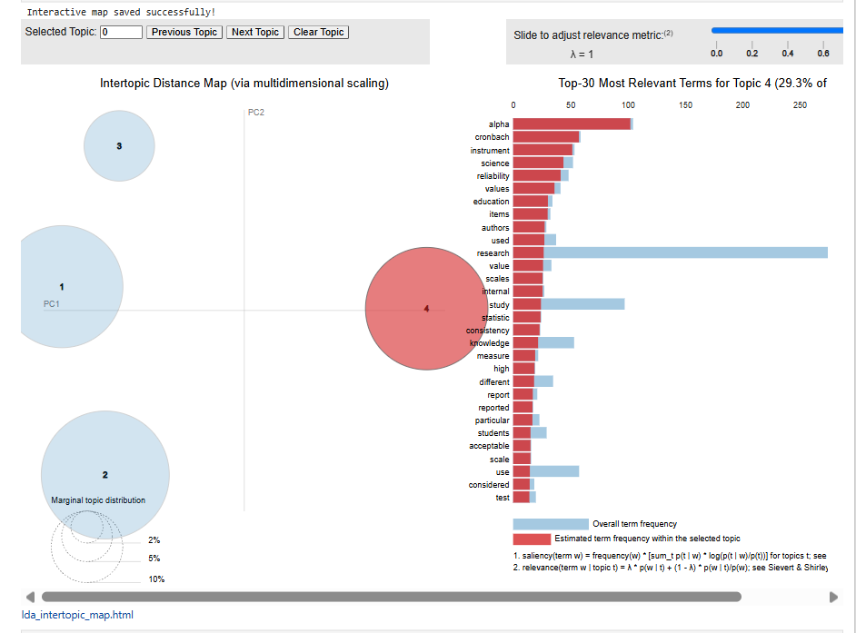

Question 4.3
Github repository link: https://github.com/EDUV4818544/ITNPA3-34-Project-1-Online-Campus-EDUV4818544

List of References:
1. Berger, R. (2015) ‘Now I see it, now I don’t: Researcher’s position and reflexivity in qualitative research’, Qualitative Research, 15(2), pp. 219–234. Available at: https://doi.org/10.1177/1468794112468475
2. Bird, S., Klein, E. and Loper, E. (2009) Natural Language Processing with Python. Sebastopol, CA: O’Reilly Media. Available at: https://www.nltk.org/book/
3. Blei, D.M., Ng, A.Y. and Jordan, M.I. (2003) ‘Latent Dirichlet allocation’, Journal of Machine Learning Research, 3, pp. 993–1022. Available at: https://www.jmlr.org/papers/v3/blei03a.html
4. Breiman, L. (2001) ‘Random forests’, Machine Learning, 45(1), pp. 5–32. Available at: https://doi.org/10.1023/A:1010933404324
5. Cortes, C. and Vapnik, V. (1995) ‘Support-vector networks’, Machine Learning, 20, pp. 273–297. Available at: https://doi.org/10.1007/BF00994018
6. Deerwester, S., Dumais, S.T., Furnas, G.W., Landauer, T.K. and Harshman, R. (1990) ‘Indexing by latent semantic analysis’, Journal of the American Society for Information Science, 41(6), pp. 391–407. Available at:
https://doi.org/10.1002/(SICI)1097-4571(199009)41:6%3C391::AID-ASI1%3E3.0.CO;2-9
7. Fusch, P., Fusch, G.E. and Ness, L.R. (2018) ‘Denzin’s paradigm shift: Revisiting triangulation in qualitative research’, Journal of Social Change, 10(1), pp. 19–32. Available at: https://doi.org/10.5590/JOSC.2018.10.1.02
8. GitHub (n.d.-a) About READMEs. Available at: https://docs.github.com/en/repositories/managing-your-repositorys-settings-and-features/customizing-your-repository/about-readmes (Accessed: 24 October 2026).
9. GitHub (n.d.-b) Adding a file to a repository. Available at: https://docs.github.com/en/repositories/working-with-files/managing-files/adding-a-file-to-a-repository (Accessed: 24 October 2026).
10. GitHub (n.d.-c) Creating a new repository. Available at: https://docs.github.com/en/repositories/creating-and-managing-repositories/creating-a-new-repository (Accessed: 24 October 2026).
11. Hunter, J.D. (2007) ‘Matplotlib: A 2D graphics environment’, Computing in Science & Engineering, 9(3), pp. 90–95. Available at: https://doi.org/10.1109/MCSE.2007.55
12. Johnson, R.B. and Onwuegbuzie, A.J. (2004) ‘Mixed methods research: A research paradigm whose time has come’, Educational Researcher, 33(7), pp. 14–26. Available at: https://doi.org/10.3102/0013189X033007014
13. Lee, D.D. and Seung, H.S. (1999) ‘Learning the parts of objects by non-negative matrix factorization’, Nature, 401, pp. 788–791. Available at: https://doi.org/10.1038/44565
14. Luhn, H.P. (1958) ‘The automatic creation of literature abstracts’, IBM Journal of Research and Development, 2(2), pp. 159–165. Available at: https://doi.org/10.1147/rd.22.0159
15. Manning, C.D., Raghavan, P. and Schütze, H. (2008) Introduction to Information Retrieval. Cambridge: Cambridge University Press. Available at: https://nlp.stanford.edu/IR-book/
16. McCallum, A. and Nigam, K. (1998) ‘A comparison of event models for Naive Bayes text classification’, Proceedings of the AAAI-98 Workshop on Learning for Text Categorization, pp. 41–48. Available at: https://aaai.org/papers/041-ws98-05-007/
17. McKinney, W. (2010) ‘Data structures for statistical computing in Python’, Proceedings of the 9th Python in Science Conference, pp. 56–61. Available at: https://doi.org/10.25080/Majora-92bf1922-00a
18. Nenkova, A. and McKeown, K. (2012) ‘A survey of text summarization techniques’, in Aggarwal, C.C. and Zhai, C. (eds.) Mining Text Data. Boston, MA: Springer, pp. 43–76. Available at: https://doi.org/10.1007/978-1-4614-3223-4_3
19. Pedregosa, F. et al. (2011) ‘Scikit-learn: Machine learning in Python’, Journal of Machine Learning Research, 12, pp. 2825–2830. Available at: https://www.jmlr.org/papers/v12/pedregosa11a.html
20. Richey, R.C., Klein, J.D. and Nelson, W.A. (2004) ‘Developmental research: Studies of instructional design and development’, in Jonassen, D.H. (ed.) Handbook of Research on Educational Communications and Technology. 2nd edn. Mahwah, NJ: Lawrence Erlbaum Associates, pp. 1099–1130.
21. Salton, G. and Buckley, C. (1988) ‘Term-weighting approaches in automatic text retrieval’, Information Processing & Management, 24(5), pp. 513–523. Available at: https://doi.org/10.1016/0306-4573(88)90021-0
22. Sievert, C. and Shirley, K. (2014) ‘LDAvis: A method for visualizing and interpreting topics’, Proceedings of the Workshop on Interactive Language Learning, Visualization, and Interfaces. Baltimore, MD: Association for Computational Linguistics, pp. 63–70. Available at: https://doi.org/10.3115/v1/W14-3110
23. Streamlit (n.d.-a) File organization for your Community Cloud app. Available at: https://docs.streamlit.io/deploy/streamlit-community-cloud/deploy-your-app/file-organization (Accessed: 24 October 2026).

